2-3 May 2026, Prague
From Touch to Dance
workshop with
Frank van de Ven (Body Weather Amsterdam)

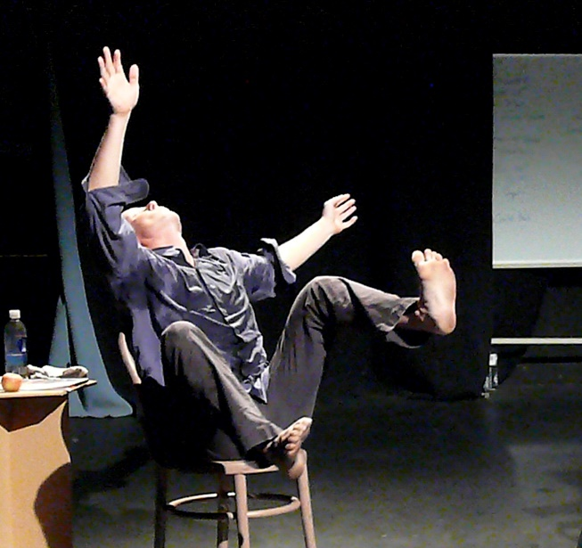
10:00 - 12.30 / Body Weather MB training
MB (mind/body, muscles/bones) is an energetic, dynamic and rhythmic movement work-out that observes the kinaesthetic sensitivity and co-ordination potential of the body-in-motion while developing strength, endurance, flexibility and grounding.

13.30 - 16:00 / From Touch to Dance
We focus on how developing multiple qualities of touch and being touched can expand one’s movement skills and vocabulary. Touch makes us aware of the world inside and outside of us. To touch is to be touched. After a clear set-up we will expand what we find into Improvisation.

Body Weather is a comprehensive training and performance practice that investigates the intersections of bodies and their environments. Bodies are conceived not as fixed and separate entities but as constantly changing - just like the weather. Weather is seen as a complex system of forces and influences coursing through and beyond bodies and the world.
As a training, Body Weather is of relevance to anyone interested in exploring the body and physical presence and this workshop is suited to dance, theatre and movement practitioners and artists of various backgrounds.

The term & philosophical basis for Body Weather was founded in the early 1980's by dancer Min Tanaka and further developed by Laboratories worldwide. Frank van de Ven was a member of Tanaka’s Maijuku Performance Company in Japan, from 1983-1991. With Katerina Bakatsaki he founded Body Weather Amsterdam, a platform for training and performance. He has an ongoing commitment to the Body/Landscape projects conducted worldwide and since 1995 he has led the annual, interdisciplinary Bohemiae Rosa Project with Milos Sejn (Academy of Art and Design, Prague, Czech Republic), connecting body and landscape with art, geology and architecture. For more info see http://bodyweatheramsterdam.nl

Studio: Plující oblaka, Jankovcova 18a, Prague
Dates: 2-3 May 2026
Times: 10:00-16:00
Workshop fee: 3000 CZK (120 eur) - students/unwaged 2500 CZK (100 eur)
Info and reservations: Katerina.Bilejova@fhs.cuni.cz

