**Vašulka Kitchen Brno & Brno Artists in Residence / Open Call 2025**

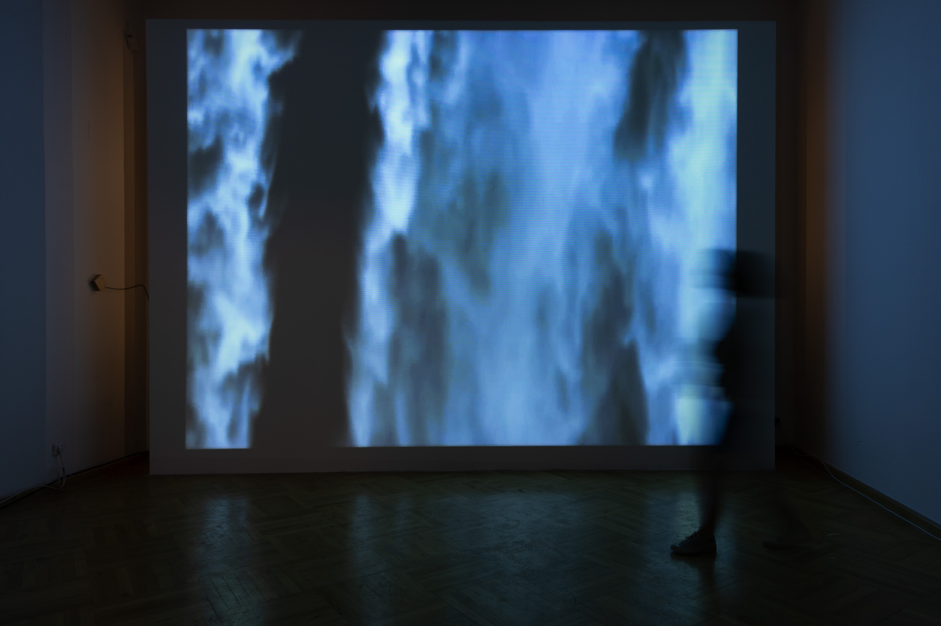

**Vašulka Kitchen Brno in collaboration with Brno Artists in Residence is pleased to announce the commencement of an international Open Call for artists and theoreticians working in the field of new media for the autumn term of 15 September 2025 through 15 November 2025.**

**The deadline for applications is 15 March 2025.**

**Brno Artists in Residence (BAiR)** has been hosting artists since 2016 and is a key constituent of the **Brno House of Arts** conceptual framework. The top floor of the House of the Lords of Kunštát has been refurbished to accommodate the residency program, providing facilities for the accommodation and work by artists in three studios.

**Center of New Media Art - Vašulka Kitchen Brno** **(VKB)** was established in 2018 as a place for research, artistic experiment and informal education in the field of new media art. It consists of the archive of Woody and Steina Vašulka and a permanent exhibition of their selected works. VKB also organizes contemporary art exhibitions, performance events and other programs to support new media creation. It focuses on preserving the artistic and philosophical legacy of the Vašulkas, pioneers of new electronic art with connections to Brno.

**General Information on the Residency Program**

The VKB residency program builds upon the legacy and oeuvre of the Vašulkas by reflecting contemporary approaches and discourses. We offer various platforms for the exchange and development of discussions on the historical and contemporary form of new media art and its application in the interdisciplinary field of art and theory. The Brno Artists in Residence and Vašulka Kitchen Brno support the realization of diverse contemporary artistic projects and favor collaborative approaches that reflect plurality and openness.

VKB's 2024 resident will be granted access to our Center of New Media Art, its digital archive, reference library, and be provided the opportunity to present their work to professional and public audiences. Residents are encouraged to cooperate with our institutional partners including the Faculty of Fine Arts, Technical University of Brno and the Theory of Interactive Media, Masaryk University. We encourage applicants to apply who are interested in the development of projects that include the involvement of local and regional experts in technical and scientific fields.

The resident will be selected through an open call review by the committee of Vašulka Kitchen Brno association members and guest evaluators. Applicants should be active artists or theoreticians in the field of new media art with a genuine interest in exploring the nature of their medium in addition to the possibilities that it lends the subject of their inquiry. The VKB resident is encouraged to present their work to the professional and general public in the form of a presentation, lecture, discussion, or exhibition at the Vašulka Kitchen Brno gallery.

We will accept applications in English, Czech, or Slovak.

Conditions:  
Brno Artists in Residence and Vašulka Kitchen Brno provides:

1. Stipendium: 40 000 CZK;
2. Accommodation and studio at House of the Lords of Kunštát, Dominikánská 9, 602 00 Brno, Czech Republic;
3. A selection of technical equipment, study room and library, and the possibility of establishing contacts with the local scene and professional community.

The resident is obliged to:

1. To be in Brno at least 75% of time;
2. Participate in programs organized by The Brno House of Arts and Vašulka Kitchen Brno for its residents including a video interview for the purpose of raising awareness of the residency program;
3. The artist undertakes to elaborate a final report with photographic documentation from the duration of the residency.

How to Apply:  
Applications must include the following documents (in PDF format only please):  
1) Motivational Letter of Intent explaining your reasons for applying, your expectations, and what you would like to focus on specifically during your residency (max. 3 000 characters);  
2) A brief informative curriculum vitae, including contact information (max. 1 page);  
3) Portfolio (max. 10 MB) For video files please provide links to your own website, or to video sharing platforms such as Vimeo, youtube, etc. Kindly refrain from sending links to video file downloads.

Please note:

* Accepted candidates are required to participate in the residence for its entire duration during the following fixed periods.
* Applications will be accepted in the English, Czech, and Slovak languages via email by: **15 March 2024.**
* Please send your application with the subject "**VKB Residency Open Call 2025**" to: [vasulkakitchen@gmail.com](mailto:vasulkakitchen@gmail.com)
* The results of the Open Call will be announced **by 15 April 2025** on The Brno House of Arts website [www.dum-umeni.cz](http://www.dum-umeni.cz/)and Vasulka Kitchen Brno's www.vasulkakitchen.org and on respective social media pages (<https://www.facebook.com/vasulkakitchenbrno/>; https://www.facebook.com/BrnoAiR).
* Successful candidates will be contacted by email.

For more information please contact us at [vasulkakitchen@gmail.com](mailto:vasulkakitchen@gmail.com) using **VKB Residency Inquiry 2025** as the subject line.