Open call: Playing Dance Writing
Apply to be one of the four writers who will participate in the seminar Playing Dance Writing happening in Bergen, Norway during Oktoberdans festival 20 - 24 October 2022.
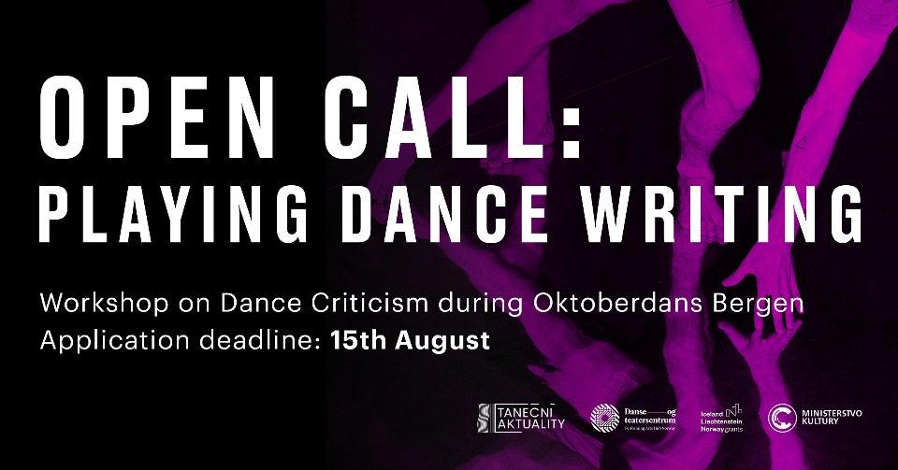
The project Dance and Performing Arts Criticism in Europe, a collaboration of Czech Dance News and Performing Arts Hub Norway, organises a three-day seminar for emerging dance critics, which will address the practice and new forms of dance criticism.

What you get:
- Free coaching seminar from professional dance critics
Participants will enjoy lectures by experienced dance writers, coaching and discussions about the seen performances, will practice review writing and the practice of dance criticism in general.
- Published review (guarantee 100 EUR per published text)
- Access to selected performances presented on Oktoberdans 2022 - contemporary dance biennale in Bergen, Norway
- Transport contribution (825 EUR per participant arriving outside from the Norway)
- Acknowledgement of participation
The seminar is for free and open to participants based in Europe, previous experience with writing about dance is not required. The language of the seminar is English. Participants will be invited to produce their own review texts. The short writing tasks will be then discussed with the lecturers and within the group. Finally, one text from each participant will be published at the website of Czech Dance News, and their authors will be rewarded 100 EUR).
The participants will reflect together what the dance criticism entails today: how to look at dance of different genres and in different formats/media, and how to reflect it in various contexts. They will also discuss new approaches to criticism, how to play with it and make it talk to its readers.
The workshop contains lectures by experienced dance writers from Czech Republic, coaching and discussions about the seen performances at the Oktoberdans festival, the texts and the practice of dance criticism in general.
Coaches and lecturers: MgA. Petra Dotlačilová, Ph.D. et Ph.D. and Mgr. MgA. Lucie Hayashi, Ph.D., both experienced Czech dance critics and representatives of Czech Dance News.

Application deadline: 15th August 2022
Fill the application form here: https://forms.gle/RY5FpcrhhsFEkzMj9
You will be informed about the results by 30th August 2022.

Preliminary seminar schedule:

Thursday 20th October
10-12:30 Forms of Dance Writing by Petra Dotlačilová (lecture and discussion on
different formats and styles of dance writing)
- approx 90 mins of individual work on the first writing task.

Friday 21st October
11-13:30 Upside Down Criticism by Lucie Hayashi (lecture and discussion on playing
with the dance writing forms and styles)
- approx 90 mins of individual work on the second writing task.

Afternoon, time TBA: Open Panel Discussion on Working Slow hosted by Anette Therese
Pettersen / Hild Borchgrevink

Saturday 22nd October
10-12:30 Make the Content Talk - final workshop session by Lucie Hayashi and Petra
Dotlačilová focused on the transmission of a text message to readers
(Group activities, discussion and feedback on the writing tasks.)
- approx 120 mins of individual work on the final writing task.

Afternoon, time TBA: Closed discussion of dance writers on the Sustainability of Dance
criticism together with Springback writers

Optional follow up (preliminary programme):

Sunday 23rd October
11:00-15:00 Seminar on Dramaturgy, Venue: Bergen Kunsthall

Monday 24th October
11:00-15:00 Seminar on Dramaturgy, Venue: Bergen Kunsthall

During the writing workshop, the participants will be expected to watch festival performances and deliver the writing tasks the same day. After the workshop, the participants will be asked to submit one dance review from the festival to be published on the website www.tanecniaktuality.cz/en. This text will be reviewed by the lecturers with possibility of individual consultations.
Join the Facebook event here for update information.
The project is supported by EEA Grants 2014-2021.
