Cultural Production and New Technology

Associate Professor Margaret-Catherine Perivoliotis
Interior Architecture and Design Department
Faculty of Graphic and Applied Arts
Technological Educational Institute, TEI, of Athens
Greece
perivoliotis@teiath.gr

Abstract
The paper discusses cultural education and aesthetic production using technologies that do not limit or over-influence them. The author addressed the question, and undertook research, on the powers, limits and possible approaches of new technology on cultural production. The project is also an alternative approach to the diachronic cultural values of ancient drama performances. Culture has made a great contribution to art and design development. From antiquity, diverse local cultures inspired artefacts around the Mediterranean littoral, founding and cultivating local design heritages. Culture, art/design production and education have become integrated by technology with a kind of cultural regeneration, but are they also influenced – or even over-influenced by it? The research attempts an equilibrium approach between culture, art, design and technology. It is part of the collaborative activities of Technological Educational Institute of Greece with European Schools of Design through the Socrates/Erasmus programmes, aiming to offer new possibilities to art/design students.

Keywords: ancient drama, textiles, new technology, cultural heritage, design education

Introduction
The hereafter-presented work is a multidisciplinary design work, part of the educational collaborations of TEI of Athens. Educators, designers, textile artists and students undertook research on the powers and limits of cultural heritage on stage design and textile production. The unique feature of this project and the case study is that it provided the opportunity for multicultural and multi-lingua European students to explore common multidisciplinary co-designing issues and discuss innovative cultural and aesthetic approaches using technologies that do not limit or over-influence them. The involved professors and design students have benefited from the research work, the exchange of insights, research tools and methods that support research, and the sharing of experience, ideas and information on education and on the application of multimedia.

The idea that motivated the present research collaboration derived from the fact that during the last years, many local stage-design production companies have produced poor designing, resulting in an ineffective presentation of the drama, with subsequent lack of attracting audience. Different factors contribute to success or failure, but often they can be traced back to the designers’ designing ability or inability of real aesthetics and of innovative human-centred design approaches (Croce, 1902, Korsmeyer, 1998). Stage designers are asked to bring aesthetic quality, innovation and human consideration to their design products if they wish to be competitive in the present highly demanding era. Design aesthetics are always closely related to critical reflection, while design innovation is linked to experimentation and practical delivery (Bender & Blocker, 1993). Innovation and design go hand in hand as any new design is effectively an innovation in itself, especially if new approaches or new concepts have been incorporated, eminently transferable, as what one designer does could benefit another. Innovation does not have to be product related, as happened in the present experiment. It can encompass new media or material in a traditional application or the use of a known component somewhere where it has not been adapted.

The approach as discussed in this paper has been applied and educated within the framework of the European funded programs with the active participation and collaboration of Moholy-Nagy University of Art and Design and Lapland University. Educators, qualified designers, artists, stage designers and representatives from technology composed the research team. Designing for an ancient drama performance was identified as a theme with common interest, due to its qualities and relevance to partners’ curricula. It is an interdisciplinary and well-known subject, part of European culture and addressed in all languages. The partners were targeting to improve the present situation of the local theatrical business that are of the greatest cultural and aesthetic value for all countries and cultures, to provide an intellectual and creative stimulus for the participating students, to encourage critical debate concerning the cultural context of textiles and ancient drama, and to assist future textile and stage designers to have successful careers.

The objectives of the project were to promote interdisciplinary inter-cultural applied research in the university environment, to analyse textiles from a cultural point of view, to address textile design teaching/learning strategies, and to facilitate a dialogue on the aesthetic and cultural powers and limitations of contemporary technological developments. The aims of the case study were to create new opportunities, visions, skills, directions and aesthetics for design students and practitioners, to explore the role of educational methodologies that lead to textiles with cultural identity, and to investigate the possibilities of innovative artefacts that result from the combined research of culture and today's accelerating technology (Fiore, & Kimple, 1997, Nijhoff, 1980). In seeking support of the hereafter work, the following data where collected, studied and delineated.

Design and Cultural Heritage
Design, according to Webster's Dictionary and Thesaurus, 1992, means, "to invent and bring into being", thus defining that design deals with creating something new not existing in nature. It is used to bridge disciplines, as problem solving by changing existing situations into preferred ones, an action that gives form and structure to environment with analysis and synthesis. Design Aesthetics focuses on design appearance and the way people perceive design products, studied mainly in terms of social and cultural factors (Kent, 2005). It is also related to the role of emotion in product designing, the study of the incorporated symbolism and its cultural and social meaning (Kivy, 2004). Design research by definition changes the state-of-the-world by the production of interesting to a community new knowledge and through the introduction of novel artefacts.
Designing can be generally defined as an activity. The activities a research community considers appropriate are its methods and techniques. The design of artefacts is an activity that has been carried out for centuries. Designing an artefact is a visual and conscious process, carried out by synthesizing visual, aesthetical and applied means, which can be expressed in physical objects, in forms and creations (Schiller, 2004). It is also a subconscious process expressing the designer inner world, marked by his/her identity. The evolution of an idea into an innovative form has always been a challenge for any designer, unknown or a famous, exercising his or her imagination and reason. The form always emerges from many factors as a result of the original concept, though it is considerably modified during the process of creation. It expresses the designer vision and culture, as far as this is possible, within the limitations of materials and techniques.

Design is also an interdisciplinary and integrative process and a professional field of practice and applied research. Traditionally, design of all disciplines has been viewed as a service within an organization—not as a strategic resource of success. This traditional view has changed and design has become a feature of marketing, economic competitiveness and the creative discipline that coordinates data to produce positive innovation. A new appreciation of the importance of design in both aesthetic and functional terms is the focus of 21st century design process.

A world without design would have been a very unpleasant one. It is what makes our world conform to our needs and desires, problem solving, changing existing situations into preferred ones. Design is also the language that expresses feelings and emotions. Creativity and innovation are the special qualities of design (Woolsey, 2000). The role of the designer’ s emotional situation is vital in any design discipline. What inspires is an individual matter. In general, one is motivated by the desire to create something new and challenging, but often inspiration is derived from one’s inner world and consists of many different inputs. It is quite often that emotion, feelings, mood, motivation, are not well understood during the design process and the design acceptance, though we have evidence that attractive and pleasing things are best buys, work better, are media of easy learning, and produce better results (Norman, 1998, 2002, 2003). Also when designers are with positive emotion, they are more tolerant of designing difficulties and problems and what is recognized and accepted as a good design is usually in balance of beauty and usability (Petroski, 1992).

The art of design stands in intimate relationship with materials, purposes, forms and styles. In many instances, depending on the form of the objects, it is also influenced by the materials in use, the manner in which the natural objects are presented, the purposes for which an object is created, as well as by the nature and the culture of the different people involved at different times, reflecting the spirit of the times, the political or religious ideas of the people, and the effects of foreign cultures (Speltz, 1994). The styles so formed are the truthful expression and presentation of the people culture of a certain area in a certain historic epoch (King, &Spring, 2001). An artefact is actually the product of its epoch rather than of a single person, and local culture is the catalyst that enables the expression of the same geometric designs seen in nature and which are inspired by the same fauna and flora in a different fashion, according to the culture in which it exists (Van Amerongen, & Cristiansan, 2002).

Social groups express their cultural values through their demands, ideologies and preferences, and their aesthetic values have been improved through the distribution of various man-made products, and via their positive or negative appreciation of them (Julier, 2000). Industrial design has presented, in many cases, a quite successful use of local cultures on a commercial scale, by informing consumers of the products and the production culture (Walker, 2002). Industrial designers have realized that it is vital to develop cultural originality and distinctiveness designing products that reflect cultural backgrounds. When this distinctiveness is reinterpreted in terms of form, image and symbolism, and is compounded into products, new human-centred products will result, and local industrial competitive powers will be definitely strengthened (Cruz, 2002). Reconsidering cultural heritage from a new viewpoint and with new media is a real design work, because during the process the designer views things without preconception. It is also a human-centred approach, in the very broad meaning of the term, since culture is a fundamental part of human nature (Ostroff, 2005). Of course if one is unfamiliar with the real culture, the attempt to recreate or unite it with industrial products can destroy both the form and the artist’s intention (Haan, 2003). It is important that designers understand old things and have renewed appreciation of local cultures in order to develop original products with identity.

Culture and heritage have made a great contribution to textile design development. Over the centuries diverse local cultural textiles have been spreading throughout Europe, Asia, Atlantic and Pacific Oceans, inspiring designs and artefacts, textiles, ceramics, furniture, decorations, thus founding local design heritages and cultivating national ones (Loebbecke, Thaller, 2005). The oldest forms of textiles consisted of geometric figures such as circles, bands, straight and curved lines, which were drawn in categorical regularity, according to a certain rhythm, and conforming to the structure of the objects they adorned. They formed the common design background throughout the Mediterranean littoral, were the basis for the spread of intellectual and technical skills, contributed to design evolution, and provided inspiration to create more sophisticated textiles and artefacts.

The Cultural Value of Textiles
Textile comes from the Latin word texere meaning to weave, with the first material used being of a vegetative nature. Clothing and other textiles are materials of enormous importance to the survival of the human race, a prime necessity with great variety and demand. They are weather protections of the body, interrelated to sex and social rank, expressing cultural characteristics and ways of living and thinking, of groups and individuals, of time periods and societies, projecting differences and similarities, capturing human nature. Textiles cover humans’ body and surroundings in thousands of variations. They hide, protect, warm, connect, separate, enchase and expose. They follow life from birth to death. These qualities and the opulent variousness and uses of textiles have made them an incomparable human creation. Textiles have mechanical, aesthetic, and material advantages that make them ubiquitous in both society and industry. Textiles transcend boundaries, as they unite and divide mankind. Changes in the appearance and types of garments through the ages are a significant indicator of social, economic, cultural and chronological changes. The mode of dress differentiates friend from foe and peasant from prince.

The symbiotic relationship of humans and textiles goes back to the pre-historic era, when the first human beings had recognized their ability to make soft, pliable material from vegetable and animal fibbers. They discovered how to spin, weave, comb and felt the elementary fibbers, thus obtaining a material in which they could wrap up themselves - the textile. Textile was born, replacing furs and pelts (Sterk, 2000). Clothing is made from textiles, and is among the first composite materials engineered by humans. Clothes began as a rectangle piece of loomed cloth wrapped around the body, inevitably forming folds, embracing it in a variety of elaborate ways, creating garments that are often distinguished by their quality and simplicity (Abrams 1993:161-165). Everyone is wearing clothing. It conveys a sense of the wearer's identity, provides protection from the environment, and supplies a convenient way to carry all the paraphernalia of daily life. Although textiles and clothing are a very important part of everyday life they are extremely perishable, depending upon climate, soil and the details of deposition. The oldest remains of cloth are linen, dating back to 6th millennium BC (Barber 1991). Unfortunately well-preserved antique textiles are the exception rather than the role.

Closely connected with the practical need of humans to be clothed is the desire for beautification of the imperative clothing with colours and patterns. From a historical point of view, dyeing is as old as the textile industry itself. According to Greek mythology Ariadne, the goddess of spinning and weaving, was the daughter of Idon, the dyer. This is an interesting chronological coincidence that shows how intimately the art of dyeing was connected with sister arts. The cultural influence of textiles vanishes in history with textiles being a great travellers’ attraction, since the Egyptian and Aegean era (Creekmore, & Pokornowski, 1982). It is evident that travelling was quite limited, at that time, to few intellectuals with curiosity. Democritus, Herodotus, Plato, Aristotle, Ptolemy were some of the well-known travellers of the ancient world. It is a fact that via those travellers curiosity, fabulous and rare textiles of the ancient world moved from country to country, inspiring local designers and craftsmen not only to create of new textiles, but also new forms, designs, decorations and culture.

In the time of past generations, the role of handmade cloth and garment was more prominent, more personal, more part of everyday life than what is commonly known today. Textiles embodied the social and cultural values and customs of their times: opulent laces and richly woven fabrics displaying wealth and prestige; fabrics of intricate detail and symbolic design for dowries, births, and deaths; richly hand embroidered and woven textiles for household adornment. In innumerable countries skilled craftspeople, coming from diverse social and financial circumstances, created textiles that were a valued and essential part of everyday life. Textiles through Time have served as link between generations and cultures, inspiring the creative imagination of the new generation (ETN, 1993).

Hellenic textile tradition, culture and heritage are living concepts, and this is proved by means of the thorough study of Greek textiles (Perivoliotis, 2005). They are still produced locally, with various unique traditional methods, materials and qualities, using traditional looms and weaving methods. Individuals and small family or cooperative firms, produce traditional textiles, mostly according to the old ways of production. Designs, which were handed down through generations reflect local history, religion and customs. Basic designs remain similar for more than 4000 years. The principal material used was wool and the specific colours, which were derived from local plants, were almost the same through the centuries, reflecting local history, religion and customs (Norris, 2000). The Traditional Balkan and Greek male costume of Foustanella, a multi-pleated and multi-folded kilt worn presently by the Euzones Guards, is undoubtedly relic of the archaic fashion, and many East Mediterranean and Greek traditional female costumes are echoing the culture and beauty of the ancient classical tunic, decorated with anthemia, spirals and scrolls.

Though no ancient classical dress has survived (Abrahams, 1908), modern designers have interpreted the classical fundamental dress forms, as they are displayed on statues, in countless ways and versions. Ancient classical pleads and folds, light and shade, continue to follow their path in history, at other latitudes and longitudes (Huston, 2003). From the so-called neoclassical dresses of the Directory period to the highly experimental investigations of the 20th century designers, Classical cloth has influenced fashion in different diverse ways, becoming a power of evolution in the hands of intelligent creators. Madeleine Vionnet’s name is closely bound with the ancient draped cloth. Her evening gowns in shades of white recall ancient Hellenic dresses. Her 1931 brilliant creation The Living Statue implied all the concepts of the aesthetic culture of classical Hellenic clothing. Issey Miyake, who is one of the most highly recognized Japanese designers, gained his esteem with a series of works of pleads and folds according to the ancient classical manner. The endlessly beauties of classical draped and pleated clothing remained over the centuries a perpetual challenge and inspiration to designers. The culture of Classical Textiles has flourished around the world, moving beyond the traditional Western sphere of influence, as designers all around the world explore their cultural, structural and thematic beauty.

Textile Design Education
Education has always been a very important factor in forming culture and design consciousness. The recently offered increasing opportunities by multimedia and the Internet have helped design educators and students to get closer to the values of culture, design and textiles. The education of Textile Design is by its very nature the education of theory and practice; they cannot be separated without irreconcilably corrupting the historic and process-based links that exist between them. Theory as an agent upon design process/practice, and design process/practice as an agent upon theory, create an intimately and undeniably bound-together symbiosis. This bond exists both in practice and in teaching processes.

Textile Design education is multidisciplinary, offering a range of textile design specialisms including print, weave, knit and mixed media. It is open and flexible, enabling to cross boundaries from one discipline to another and to direct work towards fashion, interior, craft or gallery outcome. There is a strong emphasis on visual research and drawing for design and concept development. Projects encourage self-motivation and generate personal creative languages. Textile Art and Design students are more accustomed to learning through teamwork, collaborative activities and peer assessment. Textile learners prefer a more practical, visual, approach; they are visual thinkers. They appreciate materials visually and respond well to activities that provide them with the stimulus to create something. Textile design students use a great range of tools, among which, the most popular are Web and e-mail services.

Learning in the creative subject area of textiles has been recognized as having some unique characteristics such as learning by doing, emphasize on creative and innovative thinking and on longer and more individual interactions between tutors and peers. Actually in the textile design field the greatest part of learning is independent learning. That does not degrade the role of the instructor. On the contrary, instructors help learning to take place by providing learners with resource materials and chances to test their learning, by giving them feedback on their progress and by helping them to make sense of what they have learned. Learning and teaching is often based on student-tutor communication, which takes the form of individual or small group discussions. Public presentations and critical judgments of artefacts created by students are also central to this educational context. Textile learning is resource-based. Design learning resources take many forms, including human resources and information-type resources. Nowadays, the range of media available to support textile design learning is extended due to many technological developments.

The rapid changes and increased complexity of today’s world present new challenges and new opportunities on the textile education system (Rhoades, & Sweeney, 2004). Present technology-rich educational environments use the new information technology tools and resources (Harrington, 1997). Research in the area of textile education is vital in order to ensure that academics are at the forefront of textile and clothing industry developments, the teaching is always up to date, and to prepare the graduates in an appropriate way for the world of work. Culture, textile design and education have been influenced and benefited by technological improvements. The increased pedagogical opportunities enhance student learning, intensifies competition in higher education, expands mass education throughout the industrialized world and has led to the rapid adoption of electronic technologies into the learning process. This is transforming the learning environment, promising capability, declining cost and ease of use of these networking technologies. The potential for greater interactivity, flexibility, more functionality and lower delivery costs have put E-Learning on top of the educational agenda in institutions around the world. The blending of on-ground and online education is continuous and unstoppable, making online learning a core ingredient of tomorrow’s educational paradigms.

Textile design students in today's technology-rich higher education environments are presented with unprecedented opportunities to use and integrate the new tech, technology tools and electronically accessed information resources into their academic studies (Rockman, 2004). They have access to sophisticated computer pods in which they may access state-of-the-art desktop publishing, database management, spreadsheet, multimedia, statistical analysis, systems modelling, and to a wide range of university computation services such as electronic mail, online library catalogues, and reference materials (Starr, 1996). Many have access to the computer-network leviathan Internet, with its hundreds of networks, databases, user groups, bulletin boards, information services, and library catalogues across the globe.

Using computer-mediated communications, they are able to ask questions, access information resources, and work on projects with fellow students from other countries, cultures and languages (Honey, Culp, & Carrigg, 1999). These new tools and resources are providing opportunities for higher education students to enhance the quality, width and depth of their academic studies and to collaborate with, and compete with, their peers in these new knowledge environments. Computers are powerful and flexible tools making learning more engaging, addressing the needs of individual students, providing access to a wealth of information, and encouraging students to explore and create; or they can be used in negative way, to play mindless games, access inappropriate materials, or, the worst, isolate students.

Many believe that our changing world requires reconsidering the very structure and culture of design schools, along with the teaching process and curriculum. Online education is being heralded as meeting the needs of students’ lifestyles by managing time conflicts and access from remote locations, and helping people to juggle personal commitments, but research has proved that it is not a panacea. Modern aesthetics, culture, design and the art/design education system have become integrated by technology, but are they also influenced – or even over-influenced by it? (Danto, 2003). The present work attempts an equilibrium approach between culture, design aesthetics and new technology.

Ancient Drama
Ancient Drama is fundamental diachronic part of many nations’ culture, having its roots in the ancient Hellenic religious worships (Zimmermann, 1986). The transition, from religious worship to drama, occurred around sixth century BC in Athens, according to the legend, by Thespis, who first had the idea to add speaking actors to the religious performances of choral song and dance, which took place throughout Greece. Masked actors held these wordless performances outdoors, in daylight, during religious festivals, from the Minoan era, long before the Dorian invasion. The research team addressed the issue whether there is any relation between modern theatrical performances and classical drama. Comedy and tragedy are the types of drama, which were developed and flourished in ancient Athens the fifth century BC. They have influenced nearly all the subsequent Western drama, starting with that of the Romans, with their extravagant public performances and spectacles that included everything from pantomime to mock naval battles. Opera owes its existence to an attempt to return from the Roman to the Greek type of theatre. Both French classical tragedy and 19th and 20th century Irish drama feature Greek themes. Even Brecht wrote an Antigone, and Jules Dassin's film ‘A Dream of Passion’ is based on Euripides ‘Media’. Commedia dell' arte bears a strong resemblance to Roman comedy. In modern times, many television programs echo the topical humour of Aristophanes. The contemporary proscenium theatre evolved from a modern misinterpretation of the descriptions of theatrical buildings by the Roman architect Vitruvius. Greek and Roman plays remain among the most powerful, moving, provocative, funny, biting, witty, and pertinent dramas with a lasting influence. They are part of European culture, flourishing on stages around the world, moving beyond their traditional Western sphere of influence, as directors explore their structural and thematic links with the performing arts of India, Korea, Indonesia, Africa, and Japan - to name only a few.

Drama performances combine many diverse disciplines, each of which may have their own rules of aesthetics. The designing of performances is closely related to photography, colours, lighting, sounds and music, art direction, costume design and makeup. All of these disciplines are closely inter-twined and must be brought together by the aesthetic sensibilities of the director. Costume designers use a variety of techniques to create the personalities of the drama, implementing fabric, colour, scale, references to the past, texture, harmony, transparency, accessories and embroidery. Performing arts appeal to our aesthetics of storytelling, grace, balance, class, timing, strength, shock, humour, costume, irony, beauty, drama, suspense, and sensuality (Tatarkiewicz, 1974). Whereas live stage performance is usually constrained by the physical reality at hand, film performance can further add the aesthetic elements of large-scale action, fantasy, and a complex interwoven musical score. Aesthetic considerations are also associated with the sense of vision. Performance art has adapted the digital culture of new technology, while often and consciously mixes the aesthetics of several media. Digital culture has a distinct aesthetic that produces visual and aural art. Role-playing games are often seen as a performing art with an aesthetic structure of their own.

Stage Design
Stage design is the aesthetic composition of a dramatic production as created by such aspects of stagecraft as lighting, set, costume, sound, and stage (Holden, & Sammler, 1997). Stage designers are responsible for designing stage settings for productions, from single scene dramas, where the action takes place in one room, to complex scenery and scene changes (Woodbridge, 2000). They may also become involved in costume design and to identify suitable outside locations for productions. Considerable research is necessary before design work. They produce models that are used to demonstrate the setting of stage or location, and they are often skilled in modelling. The traditional medium for conceptualisation of stage design was pencil and paper sketching that facilitated the rapid development of design ideas in a short period of time. Recently, for the conceptualisation phase of the design process, computer aided design and model making are increasingly used in theatre, film and television design work (Moody, 2002).

Stage and costume design is not a static art with fixed rules, but in antiquity neither stage-architecture nor costume/fashion design changed as rapidly as they do now. Was there an ancient equivalent of a stage/costume designer? Theatre is ephemeral by nature, but scholars have managed to make intelligent and convincing inferences about costumes and costume makers, masks, properties, wooden stage buildings, and even stage business and acting techniques. Indirect evidence has been found in vase-paintings and sculptures. Concerning costume design and since the material had to be produced in the same way and the available raw materials and dyes remained the same, changes in clothing style were likely to be variations on an old theme. It is a fact that the Ancient Theatrical Costume has received very little attention in the study of stagecraft. One reason for this is the lack of direct evidence, due to the perishability of the cloth from which those costumes were made.

Textiles and drama performances co-existence vanishes in time, since textiles have contributed to the glory of a performance, mainly for costumes of religious worships/performances, thousands of years before Christ. The use of fabrics in stage design, as draped coverings of the stage and as painted scenery, is old too. Cloths have light transparency and long lasting quality. They are flexible, light-weighed, colourful, easy to transport and transform them, inexpensive; in one word a perfect solution for low-cost performances, for moving theatres and companies that are still existing, and are culturally very important in many parts of the world. Textiles and fibres can be used in many different performances, indoor and outdoor, in antique amphitheatres and modern stages, creating with their pleads and folds the amphitheatrical environmental feeling.

Stage design can be considered as a human-centred design, in its very broad meaning, and this is how has been addressed from antiquity, due to its cultural and educational qualities. Human-centred product development is the process of product development that focuses on users and their needs rather than on technology; needs meaning here physical, mental, cultural, and aesthetical. The human centred approach of the present work applies to the design of the entire project, considering cultural, social, emotional, physical and aesthetical factors of participants/designers and receivers/participants (Perivoliotis, 2004).

Research Methodology
A method is a set of steps, or guidelines, used to perform a task. The research activities and the interaction/participation between partners were studied in order to build a successful work methodology (Lakatos, 1978). The task started with research, continued through didactic strategy definition, requirements and application, concluded with the design process and technology adoption, and finished with performance presentation and evaluation. The working group was an interdisciplinary, multidisciplinary team. The research activities and the interaction between partners were studied in order to build a successful research methodology. Teamwork is an area that requires delicate handling, as power relationships can begin to emerge. If clumsily handled this can lead at best to hurt feelings, and at worst, a failed project. In order to identify the designing paths, the research team studied selected parts and scenes of well-known classical dramas, international stage and costume design productions and presentations, ancient statues and fragments of fifth-century pottery representing drama, stage, actors and chorus wearing everyday clothing, boots, masks and richly pleated chitons in purple and gold. The participating students selected a single scene of their choice from the spectrum of ancient drama, focusing on costume and stage design. The archaic way of religious performances offered the idea to replace the actors’ words with the international language of design, of textiles and textures, of shades and colours, thus expressing action, feelings and emotions. The participants academic background of design/interior design was more that adequate, since all were familiar with interior and basic costume design, basic art applications, modelling, history of architecture, design and furniture, and application of modern technology.

The adapted design research methodology had the following structure:
- Awareness of Project/Problem: Awareness of problem comes from multiple sources. The output of this phase is a proposal, formal or informal, for a new research effort. Out of the detailed analysis of the present situation of local theatrical enterprises and of the possibilities of new technology emerged the first awareness of the problem on which the research would focus: how to design and present a performance with cultural quality and identity, adapting new media and technology (Sandholtz, Rignstaff, & Dwyer, 1998).
- Suggestion: The suggestion phase follows immediately behind the proposal and is intimately connected with it. There were many approaches to the problem and the research group discussed them over a period of months. New insights into the problem continued to emerge from the students’ undertaken applied research. During the alternating cycles of discussions, reading and individual cogitation that characterized the design research efforts, the adaptation of new technology as means of artistic expression/creation for the present assignment was identified as the best answer to the request for innovative design creation/application. An asynchronous communication system was adapted among the long distance partners for fast and flexible communication.
- Development: Design is implemented in this phase. The techniques for implementation will of course vary depending on the artefact to be constructed. In the present work the participants, with the pre-determined criterion of the cultural quality of the performance designing, implemented technology with the characteristics of a paradigm, and presented their designs by technological means.
- Evaluation: Once constructed, the artefact is evaluated according to criteria that are always implicit and frequently made explicit in the proposal (Awareness of Problem phase). Deviations from expectations, both quantitative and qualitative are carefully noted and must be tentatively explained. In a sense evaluation takes place continuously in a design process, since a large number of “micro-evaluations” take place at every design decision.
- Conclusion: This phase is the finale of a specific research effort and the result of being satisfied from the total work/product. The knowledge gained in the effort has facts that have been learned and can be repeatable and successfully applied, or may well serve as the subject of further research.

The Case Study
In the present case study six educators, professors and tutors collaborated with forty design students from the three participating institutions. All students had general and interior design education, and basic knowledge of new design technology. The experiment was arranged in major groups and in small ones of one, two or three participants, according to their personal wish, their level of education, and their semester of attendance. They were asked to design for live performances and to deliver one with the assistance of technology. All had to follow a similar work procedure that lasted the same time period. The experiment was repeated three times, in different periods, places and Universities, and with different groups of students. The case study included processes and resources that assisted the multicultural, multilingual participating students to undertake research in an effective way (Gayeski, Sanchirico, &Anderson, 2002). It was decided that the didactic approach should employ two actions.

The first included a data selection method, by asking all participating students to photograph or sketch all forms of designs and items that inspire and help them to visualize the assigned performance (Perivoliotis, 2004). An important issue of the teaching methodology was the involvement of all the participants in activities that allowed them to get close to information and gain access to data. They were assigned to inquire libraries, theatres, cinemas, museums, archaeological sites, and select information photos and slides on drama, theatre and theatrical performances; to attend performances and presentations in different theatre and places; to see videos and DVDs with international performances. A rapid virtual access to the places and people of their choice was offered to all of them, through a combination of activities and visits, as a part of their education programme. Within introductory sessions they discussed the technical and design aspects, the organization and implementation of technology, of designing, of techniques and technologies and how they could solve the technical and digital problems (Woolsey, 2000).

The second action was the designing and creation process that resulted to a live performance. The didactic approach had three basic elements. Vision: It is of the utmost importance, to present an image, show how it will appear, and give an idea of the character of the finished object - for the present work the visualization of the performance event. Proposal: This is the element that gives form to vision – here, the designing that followed. Motivation: It is the rational and technical element of the design process made up of general and specific goals – an innovative cultural approach to ancient drama with modern means/technology. The design sessions were expanded with lectures on construction, style and composition and also with a discussion of aesthetics (Goldblatt, & Brown, 1997). They included short video, slide and image presentations on performances. The students were supported both in content and in process by direct support by supervisors, by methods and application of research during the fist part of their assignment, and by techniques that would assess their levels of creativity and innovation during the designing part of the assignment. The adapted teaching/learning strategy was concentrating on the learning side of the teaching-learning equation.

Various elements and constraints were considered including the design production cost. The final design proposals were selected among hundred of sketches that were created during the project. A self-imposed restriction was necessary to participating students’ enthusiasm, efforts and untiring energy, if chaos was to be avoided: to re-stain from the total spectrum of designs and to focus on those distinctively related to the character of the research.
The educational parameters, as defined by the research team, were:
-Emphasis on teaching/learning inputs/outcomes,
-Emphasis on attitudinally based "deep" learning,
-Wide variety of learning tools and assessment instruments,
-Lecturer/student relationships,
-Individual and team assessments.

Each participating group after one semester’s work proposed and presented for evaluation designs, inspirations (Figure 1), and research on the possible ways, means and media for the application of their design ideas in live performances with the implementation of technology. The research team evaluated the works, and than they were turned back accompanied with written remarks and statements, thus helping the participants to work on their proposals completion with the best possible results. Finally, the participating students presented a live performance in front of their colleagues, educators and the research team (Figure 2).

Two performances took place at the auditorium of the Technological Educational Institute of Athens and a presentation at Lapland University that had none of the characteristics of a traditional stage performance. The scenery was created by two to four overlapping designs that were parallel projected by slide/video/overhead projectors. Costumes were “designed” by projected overlapping images, created and developed by computer work. Costumes, from white veil cotton fabrics, combined the aesthetics of the ancient hiton with a “touch” of contemporary fashion (Santayana, 1955). The participants created all the projected designs during the design sessions. There were no actors, only silent figures, moving according to the archaic manner. Colour was applied via the projectors and unusual to extreme colour combinations resulted.

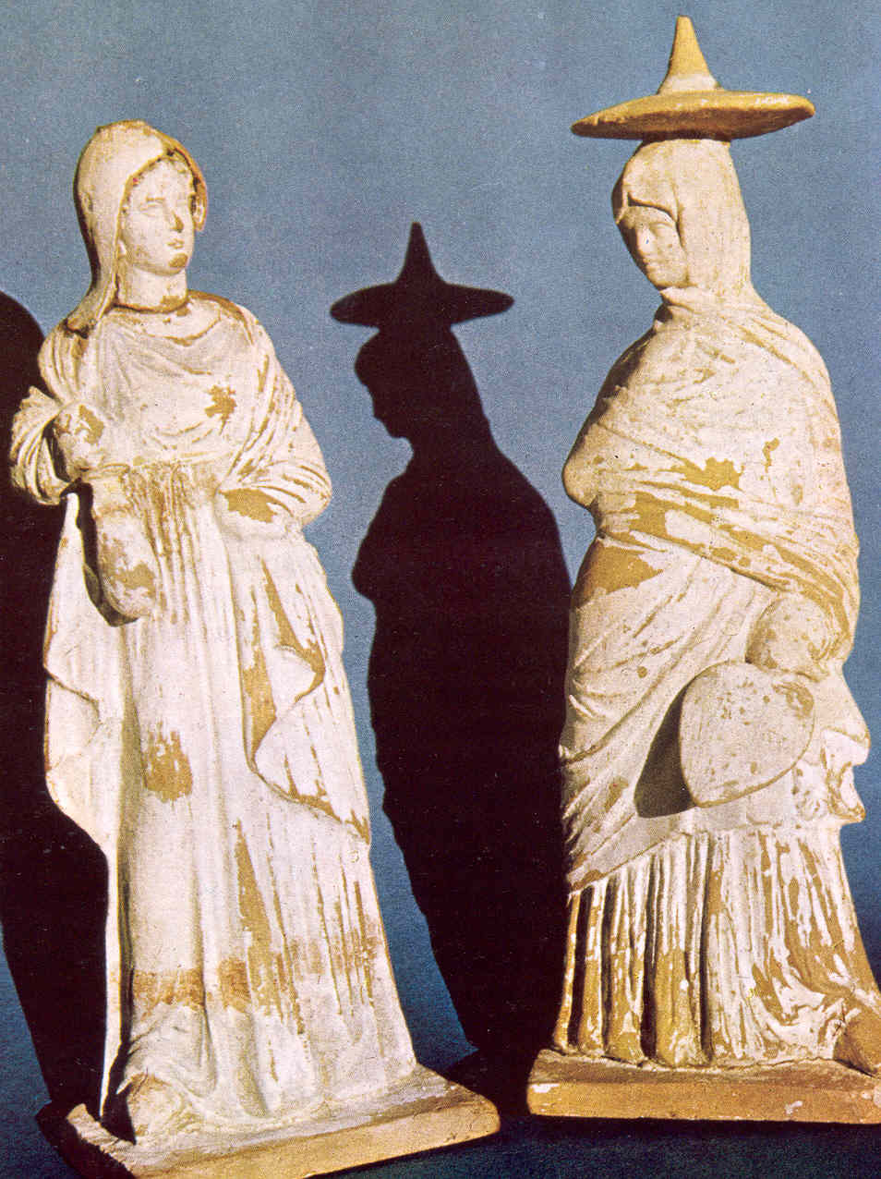
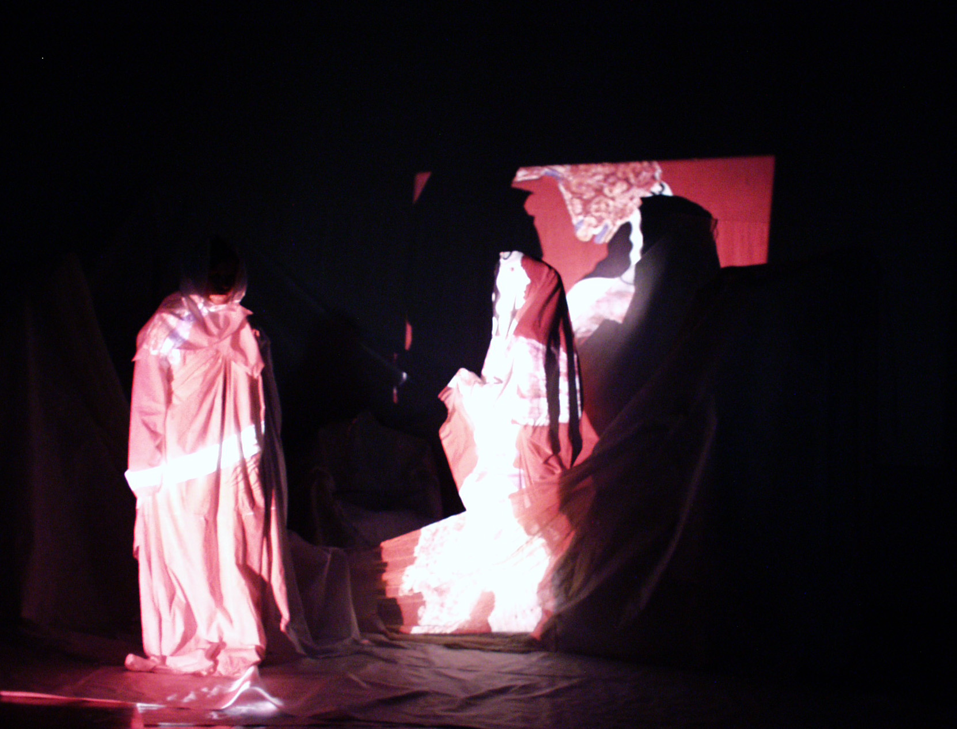

1 2

Figure 1 Example of the students collected data, during their field and desk research work, are the two terra-cotta statuettes, 4th century BC, from the Athens National Museum. The costumes and the overall structure of the female bodies inspired costumes, the actors’ positions and movements, and the total stage design of the performance.
Figure 2 Statuettes of image 1, inspired costumes and scenery, “designed” by projected overlapping images, created and developed by computer work.

Selected electronic sounds and music from archaic instruments accompanied and completed the emotional atmosphere and the aesthetics of the performance (Figure 3, A, B). The participants were free to select any media or computer program they preferred in order to design and present the performance. The final, in many cases abstract, design/colour decisions and combinations, were presented together with the prototype inspirations in layers with the multiple parallel use of video/slide/overhead projectors, and with the assistance of selected electronic lighting systems. Craft paper, fibbers and fabrics were also used in order to “build” scenery and form figures. All these elements were substituting words, costumes and scenery, embodying everything and everybody, creating a magical and altogether mythical atmosphere for the participants and the audience. Eyes became the gates for all kind of words, actions, forms, feelings and emotions. Drama and action were expressed by continues design projections, connecting and presenting the myth, and by colours and sounds that were magnetizing the audience. Images and sounds were the speaking elements, giving the general idea of the myth, the time and place, as well as the meaning of the performance. Lighting and shadow contributed to the general atmosphere. Linguistic differences/difficulties/disabilities were minimized. A new aesthetic approach to ancient drama was created and presented by the multicultural students, expressing also their ideas and culture (Figures 4, 5, 6, 7).

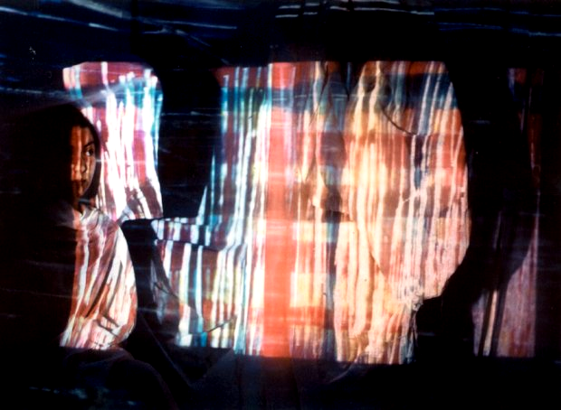
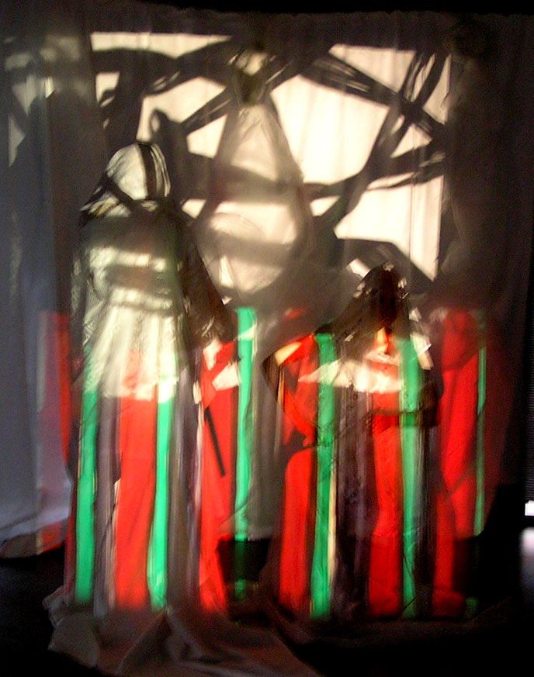

A B
Figure 3 Volumes, colours and shades were applied via the projectors and unusual/extreme colour and forms resulted, A, expressing feelings and emotions, creating new aesthetics, B.

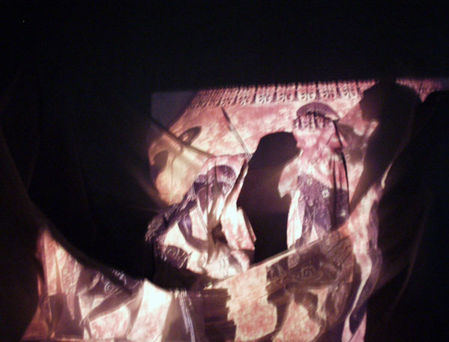

Figure 4 Example of the participating students stage design work with multiple projected images, presenting the myth and the era. The international language of designs and colours was the medium of the drama event. The total scenery was constructed from craft paper and cotton veil fabrics.

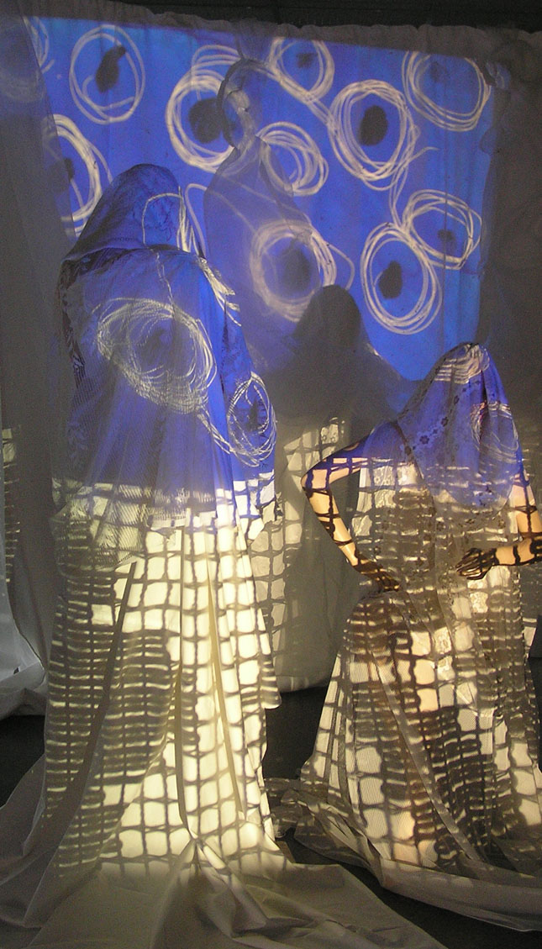
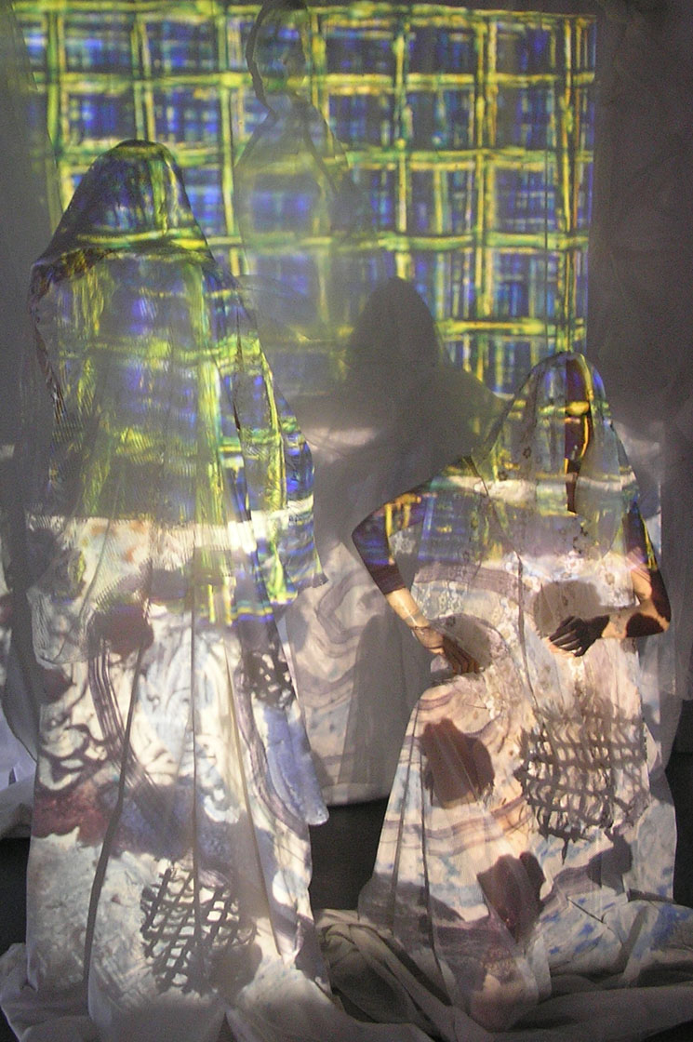

Figure 5 Examples of the participating students costume design work with multiple projected images. The students experimented on the same scene repeatedly with different design projection, colour combinations and lighting systems’ implication before their final decision.

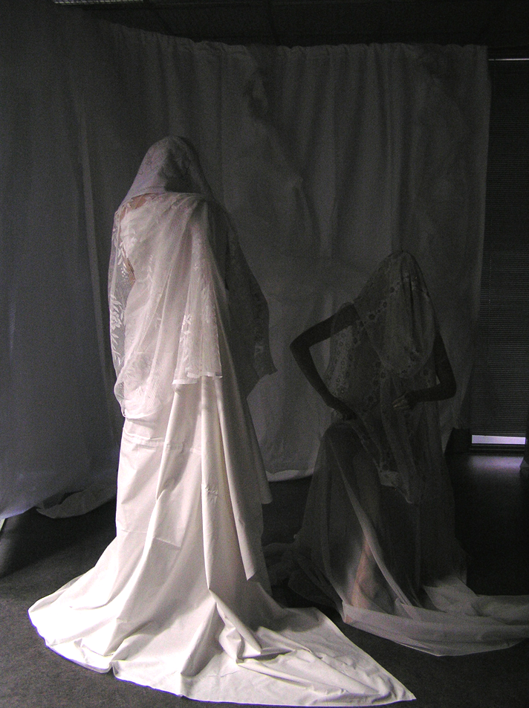
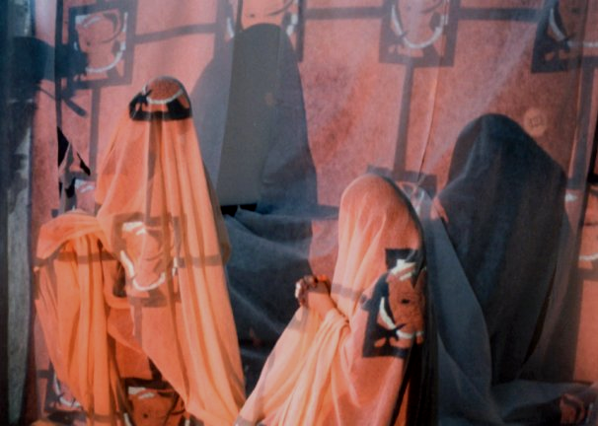

B

A

Figure 6 Costume design was a very important factor of the aesthetic quality of each performance. A: Costume structure was first tested on mannequins in order to identify materials and textures. Costumes many times had a diachronic or/and global identity.
B: Multiple projected images, presenting the myth and the epoch completed the costumes’ designing, homogenised with the scenery.

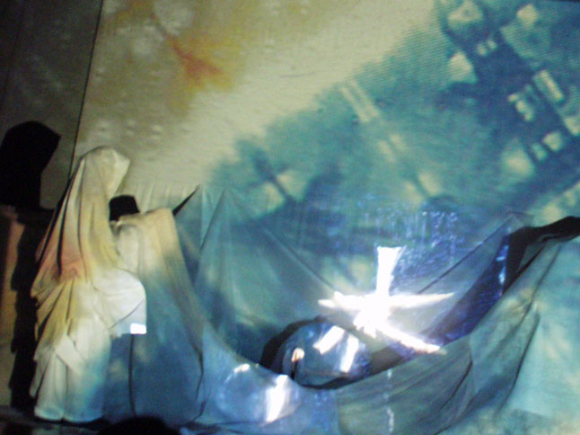

Figure 7 Ancient Textile Arts and Crafts were employed for the designing and construction of scenery and costumes. Many cloths were first treated with tie-dye, block printing and batik work, used also for the video projections. Lighting was fundamental part of the final design.

Conclusion
The case study offered many important outcomes for both the research team and the participating students. The successful educational synergy proved that players from distant cultures and production systems could create innovative aesthetics that bear the hallmark of cultural identity. Initiative, imagination and the application of technology make possible the production of technological oriented cultural qualities, implicating students and educators of different cultures and languages. The application of technological achievements can successfully create new aesthetic and cultural approaches on the ancient and modern drama performances. Design research is successful when cultural interaction, multidisciplinary knowledge, and technological transfer are creatively coordinated.

Modern technology is a valuable tool that does not only acts for sharing knowledge; it also provides new aesthetics, culture, innovative designs, improving sensibility and expressing emotions. Language differences are not barriers in the design society; the language of design can equally and powerfully communicate ideas and emotions, with technology acting as a positive medium.

Research and practice cannot be seen as separated parts, as well as design education and technological improvements. They are partners of conversation and they should be equally balanced. To make students aware of this, instructors should trigger them to be more interested, by enjoying the research part and the creation that results, and by showing them that the project will embody their visions, emotions and aesthetic approaches/preferences.

The present case study could provide a working model for developing future projects though design education and technological applications, which will involve Universities, professors and students that share the same extensive cultural sensibility, aesthetics, feelings and vision. This exploration hopes to stimulate further research on the processes in which modern technology plays an important, vital role in creating and sharing cultural data. The recently growing and enduring emphasis for technological applications in design and design education could open new horizons to students with sensibility and spirit for innovation, if the cultural dimension of designing is not lost in the process. Design knowledge and design thinking, society and people should move towards the Design most unquestionable quality: cultural inspiration for a more “human-dimensioned” approach.

References
- Abrams, H. Textiles 5,000 Years: An International History and Illustrated Survey, Harris, Jennifer, Inc., Publishers, pp. 161-165, New York, 1993.
- Abrahams, E. Greek Dress, London, 1908.
- Barber, E. J. W. Prehistoric Textiles, Princeton University Press, 1991.
- Bender, J. & Blocker, G. Contemporary Philosophy of Art: Readings in Analytic Aesthetics, Prentice Hall, 1993.
- Creekmore, A. & Pokornowski, I. Textile History, University Press of America, Washington, 1982.
- Croce, B. Aesthetic as Science of Expression and General Linguistic, Macmillan and co, 1902.
- Cruz, Cayetano, Strategic Program for development and expansion of the cultural, industrial and architectural heritage, 2002.
- Danto, A. The Abuse of Beauty: Aesthetics and the Concept of Art, The Paul Carus Lectures, 2003.
- ETN, A Sectoral Catalyst of Creative Energies for a Europe of Cultural Regions in the Council of Europe’s Cultural Leading Program, ETN Conference Proceedings, 1993.
- Gayeski, D., Sanchirico, & Anderson, J. Designing training for global environments: Knowing what questions to ask, Performance Improvement Quarterly, Vol. 15, No 2, pp. 15-31, 2002.
- Goldblatt D. & Brown, L. Aesthetics: A Reader in the Philosophy of the Arts, Springer, 1997.
- Fiore, A. & Kimple, P. Understanding aesthetics, Fairchild Publications, 1997.
- Julier, Guy, The Culture of Design, Sage Publications, 2000.
- Haan De G. Design for Global Access to Cultural Heritage, Maastricht Mc Luhan Institute Maastricht University, The Netherlands, 2003
- Harrington, L. Technology Works Best When It Serves Clear Educational Goals, Harvard Education Letter Vol. 13, No. 6, pp. 1-5, 1997.
- Holden, A. & Sammler, B. Structural Design for the Stage, Focal press, 1997.
- Honey, M., Culp, K., & Carrigg, F. Perspectives on Technology and Education Research: Lessons from the Past and Present, U.S. Department of Education, Secretary’s Conference on Educational Technology Proceedings, 1999.
- Huston, M. Ancient Greek, Roman and Byzantine Costume, Dover Publications, Minneola, 2003.
- Kent, A., J. Aesthetics: A Lost Cause in Cartographic Theory? The Cartographic Journal, 42(2) 182-8, 2005.
- King, B. & Spring, M. The Design Process in its National/Regional Context, Design Journal, No 3, pp 4-18, 2001.
- Kivy, P. The Blackwell Guide to Aesthetics, Blackwell Philosophy Guides, 2004.
- Korsmeyer, C. Aesthetics: The Big Questions, Oxford, Malden: Blackwell Publishers, 1998.
- Lakatos, I. The Methodology of Scientific Research Programmes, Cambridge University Press, 1978.
- Loebbecke, C. & Thaller, M. Preserving Europe's Cultural Heritage in the Digital World, European Conference on Information Systems (ECIS), Regensburg, Germany, May 2005
- Moody, J. The Business of Theatrical Design, Allworth press, 2002.
- Nijhoff, M. A History of Six Ideas: an Essay in Aesthetics, The Hague, 1980.
- Norris, H. Ancient European Costume and Fashion, Dover Publications, Minneola, 2000.
- Norman, D. The Design of Everyday Things, The MIT Press, 1998.
- Norman, D. Emotional Design, Basic Books, 2003.
- Norman, D. Emotion and design: Attractive things work better, Interactions Magazine, Vol. Ix, No 4, pp. 36-42, 2002.
- Ostroff, E, Universal Design in Cultural Settings, Global Universal Design Educator's Network Westport, Massachusetts, USA, 2005.
- Perivoliotis, M., C. Emotion and Design in Theatrical Performances, Design and Emotion Conference Proceedings, 2004.
- Perivoliotis, M., C. Design Education Among Students of Different Cultural Backgrounds: A Textile Design Case Study, Cumulus Utrecht Conference Proceedings, 2004.
- Perivoliotis, M. C. The Role of Textile History in Design Innovation, Textiles History Journal, May/2005.
- Petroski, H. The Evolution of Useful Things, New York, Random House, Vol. 1992a, 1992.
- Rhoades, B. & Sweeney, K. Changes in the teaching and learning process in a complex education system, Necsi Research projects, 2004.
- Rockman, S. Leader’s Guide to Education Technology, National School Board Foundation’s, 2004.
- Sandholtz, J., Rignstaff, C., & Dwyer, D. Factors That Affect the Effective Use of Technology for Teaching and Learning: Lessons Learned from the SEIR-TEC Intensive Site Schools, Greensboro, SEIR-TEC, 1998.
- Santayana, G. The Sense of Beauty. Being the Outlines of Aesthetic Theory, New York, Modern Library, 1955.
- Schiller, F. On the Aesthetic Education of Man, Dover Publications, 2004.
- Speltz, A. Styles of ornament, Gramercy Books, New York, 1994.
- Sterk, B. New departures in textiles, Textile Forum, No. 2/2000.
- Starr, P. Computing Our Way to Educational Reform, American Prospect, No 27, pp. 50-60, 1996.
- Tatarkiewicz, W. History of Aesthetics, 3 vols, The Hague, Mouton, 1974.
- Van Amerongen Raphael, Cristiansan Henri, The relation between culture and design, 2002.
- Walker, Stuart, Beyond Aesthetics, Identity, Religion and Design, Design Journal, 2, 2002, p. 30-41.
- Woodbridge, P. Designer Drafting for the Entertainment World, Focal Press, 2000.
- Woolsey, A process of evolution, Fiberarts, Vol. 27, No. 3, pp. 12, 2000.
- Zimmermann, B. Greek Tragedy - An Introduction. Johns Hopkins Press, 1986.

Contact details

Assoc. Prof. Dr. Margaret C. Perivoliotis
Interior Architecture and Design Department
Faculty of Graphic and Applied Arts
International Academic Coordinator
Technological Educational Institute (TEI) of Athens
University Address:
Ag. Spyridonos Street, Egaleo
12210 Athens, Greece
Home Address:
93 Agiou Meletiou Styreet,
11251, Athens, Greece
Phone: +302108678277, +302105385423
Fax: +302105385423
Email: perivoliotis@teiath.gr

Word count: 7202

